DDA Annual report 2023-2024 - Text only version
People from multicultural communities with disability leading change. Coming together. For ourselves. For our communities.
Diversity and Disability Alliance is a user-led and peer-led disability support organisation, run by and for people with disability from diverse backgrounds with the support of families and allies.
We support people ﻿to live the lives they choose. We believe that each person with disability has the right
to a genuine voice, choice, and control of their lives and participation in genuine and meaningful inclusion in the social, economic, cultural, and political life of the communities in which they choose to belong.
Our core business is peer support. We draw on our common lived experience and our diversity and usehttps://docs.google.com/document/d/12_LEkc--GvP3ItzkfnQIhbACaPzbipE-DfI7PG8-x_I/edit?tab=t.0
peer support to create change.
We are an independent, collective voice committed
to diversity and full inclusion.
Our Vision
An inclusive, diverse, and just society where people with disability have a voice, choice, and control over their lives.
What we do:
Maximise and build the knowledge, skills, and capacity of people with disability, their families, and allies from diverse backgrounds
Build the capacity of all communities to include people with disability
Share our collective lived experiences
Contribute to a society where the diversity
of our communities is valued and our rights contained in principles and articles of the United Nations Convention on the Rights of Persons with Disability are upheld.

Presidents message
Image description: Photo of Pauline David

As we reflect on 2024, I am proud at how Diversity and Disability Alliance (DDAlliance) has continued to grow and thrive as a peer-led organisation, working to remove barriers and promote inclusion for people with disability from culturally and linguistically diverse (CALD) backgrounds. Our last financial year has brought incredible opportunities for connection, development, and systemic change, firmly establishing DDAlliance as a leading voice in the disability community.

Achievements of the Year
We focused on building the capacity of our peers and staff through two impactful professional development days. These sessions strengthened our collective ability to advocate for and with our communities. We continued facilitating our peer cafes, coming together to share and build our knowledge and expertise on topics such as the NDIS, education, employment, health and well-being

We also took part in numerous expos, where we were not only stallholders but active participants in engaging with the CALD disability community. These events have helped expand DDAlliance’s visibility and reinforced the crucial contributions of our peers in creating a more inclusive society.

While we celebrated many achievements, we also encountered challenges. With the conclusion of our ILC funding and our ineligibility for the NDIA Peer Support Grant due to being mentioned in a grant submission with CDAH, we faced tough decisions. Regrettably, this meant saying goodbye to three valued team members—Catherine, Rhiannon, and Andrew. Their contributions will always be appreciated, and they remain an integral part of DDAlliance.

Despite these challenges, we successfully secured two community grants: one from Canterbury Bankstown Council and another from Ryde Council. These grants will enable us to continue addressing barriers and fostering greater inclusion in our communities.

Acknowledgments
None of this work would be possible without the dedication and commitment of our team. To our board members, staff, peer workers, and volunteers—thank you for your unwavering efforts to advance our shared mission. Together, we are dismantling systemic barriers and creating opportunities for all people with disability to live the lives they choose.

Personal Reflection
As President, I am both humbled and proud of what we have accomplished this year. Leading an organisation like DDAlliance is an honour, and I am continually moved by the resilience, passion, and strength of our peers and communities. The challenges we’ve faced have underscored the importance of solidarity and have strengthened my commitment to advocating for systemic change and amplifying the voices of people with disability.

Looking Ahead
As we move into 2025, I am eager to explore new opportunities and securing DDAlliance as the go to peer- led organisation for people with disability from CALD backgrounds. Together, we will navigate this journey, guided by our shared vision of a world that celebrates diversity and values the contributions of all people.

Wishing you all a safe and joyful holiday season. Thank you for your incredible contributions to DDAlliance. I look forward to continuing this vital work with you in the year ahead.

Pauline David
President - Diversity and Disability Alliance

List of Board Member 2023-2024

President: Pauline David
Vice President: Julie Magill
Secretary: Paul Seo
Treasurer: Ismail Khan
Board members:
- Mark Tonga
- Mirella Manna
- Sozan Georgees
- Qian Fang
- Sophon Neang
The Board held 6 meetings in 2023 - 2024

Coordinator message
Image description: Photo of Ace Boncato

We wrap up another incredible year at DDAlliance, and what a year it's been! With all the ups and downs throughout the year, our projects have continued to flourish.

This year marks the final year of our ILC projects. Although, amidst our numerous efforts, unfortunately, we have not been able to secure further funding. But we have made sure to end our ILC projects on a high note!

Through ‘Connecting Peers Cross Culturally’ we've continued to further expand our diverse team of Peer Facilitators, grow as an organisation and work on the development of peer support structures within diverse communities.

The ‘ NSW Peer Learning Hub’ has seen us continuing our work with our sister organisation, Community Disability Alliance Hunter (CDAH) to take peer support to the regions and develop our Community of Practice.

The ‘Powerful Peers’ project has given us the opportunity to build on our strong foundations, grow our team of peer mentors while refining and further developing peer mentoring skills.

Our circles of support work has this year continued to flourish, with positive outcomes well beyond our expectations, as we facilitate circles while further building awareness about circles of support in diverse communities.

In our evaluation project, our team of Lived- Experience Researchers who have been working with Carrie Hayter Consulting and Meredith Tavener completed the final report: ‘Exploring benefits and challenges of peer support for people with disability in peer support organisations: A co-production project’.

Our team also presented in numerous forums and had their work published in the British Medical Journal. Through this area of our work, we have proven that lived experience is an expertise that is essential in evaluation and research work.

With no funding beyond 30 June 2024 to do or core work, we will unfortunately have to operate under a reduced capacity until we are able to secure funding. We will need to stop some parts of our work while look at different ways to continue our other areas. This also means having to forego our office space in Parramatta and reduce the size of our team; a very tough blow.

However, we have proven how agile, responsive, resilient and strong our organisation is time and time again. We've also secured a small amount of funding through a new project in partnership with CDAH, as well as a few small-scale grants. We will continue to thrive.

As we make our way into the next chapter, I would like to take this opportunity to thank my peers. You are the very fabric of DDAlliance and the reason why we have such a richness of knowledge and diversity. I look forward to continuing to work with you to further build our network of expertise, whilst challenging community norms to ensure people with disability are at the front and centre of decision-making processes, policy development and community initiatives.

To my team of staff, who often go above and beyond, supporting us to achieve our project outcomes. Joyce, Bill, Rhiannon, Catherine, Andrew and Tammy, it has been an absolute joy to work with each of you!

To our advisors and our DDAlliance board, led by our President, Pauline and our Executive team. Your support throughout this year has been invaluable. I really appreciate the time and commitment you continue to put into our organisation to ensure it remains dynamic and vibrant.

With much change coming our way, I look to the future with hope, in the comfort that our DDAlliance community will work together to ensure we continue to thrive. There is much work to be done in ensuring an inclusive, diverse and just society where people with disability have voice, choice and control over our lives. This will only happen with us, people with disability leading the way within our diverse communities. Nothing without us!

Ace Boncato
Coordinator

Image Description: Development day
Peers seated infront of a screen with Ace on the screen talking to the group
Image Description: Photo of DDA team members and members of the DDA Board all smiling looking at the camera.

Our year in review

The year of 2023-2024 had been a busy year, with a lot of activities that been happening at DDAlliance.
As you can see from the photos below, we have done a range of different activities over the year.
The most recent one was the Lidcombe Expo where two peers promoted the organisation,
Also in August 2023, We had our own version Supernova show and a few lucky peers were learned how to edit a video about their Supernova event they attended. This was thanks to Tiger who gave them a lesson in film direction using Adobe.
The Chinese Disability Peer Support Network and Eastern Suburbs Peer Café attended the St George Migrant Information Day to promote our organisation.
Another group of peers attended the Able Meet Expo at Bankstown Sports Club to promote DDA.
Another group attended the Disability Pride Festival at Ashfield Town Hall.
The Lebanese Muslim Association raised awareness of Peer Support amongst school leavers. This provided an opportunity for school leavers to learn about peer support.
DDA peers attend the Community Expo “Towards Inclusion” which promote DDA in a range of ways. DDA peers had an active role in this community event which was the opportunity for non NDIS service providers to hear peers talk about their life experiences
At the end of last year, we had a Hybrid meeting where some peers attended in the office and some attended online. We spoke about peer support and sharing resources and options.
We launched a new website on 31st July 2023,
We celebrated International Day of People with Disability (IDPwD) on 5th December at Fairfield Youth and Community Centre. There were talks from peers. Several service providers joined us on the day.
Before we close for 2023, we had an end of year party attended by peers to celebrate the end of another successful year.
In 2024, DDA had Development days on three different days. This was the wonderful opportunity to learn from each other through a range of different activities that were run by peers.
Bill Zhao
Office/Admin Assistant

Image Description: A collage of Expo’s attended
DDA peers and team workers are smiling towards the camera. In front of them is a table with a table cloth that reads " D+DA" with a sub heading that reads "Diversity and Disability Alliance" beneath. There are an assortment of paperworks and drinks on the table.

Image description: International Day people with disability A group of people sitting in the camera sitting and faced away from camera
COS play animation
Six people on the table looking at the screen and on the table there are three laptops opened and there are snacks.

Image description: End of year celabration. 15 peers sitting around a table looking at the camara and food on the table
Image description: Collage of photos at the Towards Inclusion Expo: Group of people looking to the front listening to peers stories and the panel

Image description: Website Launch: Four photos from the website launch at the DDA office. Many different peers in the board room and more peers on zoom and lovely DDA cupcakes.

Image description: Photo collage from the development day. Six different photos from the day
Image description: Photo collage from the development day. five different photos from the day
Image description: Photo collage from the development day. five different photos from the day

Connecting peers cross culturally

Overview
Connecting Peers Cross Culturally is a project that supports peers in CALD communities to build and sustain peer support networks and access peer to peer learning opportunities. Through this project we are expanding peer support networks and building a confident, skilled peer workforce.

Training
Throughout the second half of 2023, our team of peer facilitators and staff reviewed all training resources for Introduction to Peer Support and Peer Facilitator Trainings. Peer facilitators led this process, updating the materials based on their experiences and insights gained from the training. This was also a good opportunity for us to revisit the materials as a refresher!

In 2024, we held three DDA Development Days. These days provided an opportunity for our DDAlliance team to meet in person and connect with each other, reflect on our work, learn new skills and plan for our future. We had workshops in public speaking, storytelling, reflective practice and promoting peer support, team building activities, created a “Peer Tree” and had strategic activities to reflect on our past and plan for our future. These days were planned by peers and allowed us to come together and grow as a team.

I like to see my peers and share experiences. We have profound conversations. We have many different topics. When I’m concerned about anything, like the NDIS Review, I can’t wait until Monday to see my peers who are experts. My peers can give good advice. We talk about how to prepare and find solutions, such as talking to my NDIS plan manager and NDIA. I not only have the benefit from the CALD Peer Café on Mondays for myself, I invite my Khmer peers as well to join. The CALD Peer Café on Mondays is valuable. I can tell my friends, my family, and allies in the community what is amazing about peers, peer support and peer connection. Let the world know – nothing about us without us.
- Sophon, peer facilitator and peer mentor

Bringing peer support to new communities
We held Introduction to Peer Support Training online via Zoom in 2023 and in-person in Campbelltown and Newcastle in 2024. We then held Peer Facilitator Training in 2024. Peers in the Spanish, DeafBlind, Indian and Lebanese communities have now become new peer facilitators. We worked with peers, family members and allies to share information about peer support and build connections in new communities. Peers attended many expos to promote peer support and engage with new peers, including: Disability Pride Festival in Ashfield, Towards Inclusion Expo in Crows Nest, Northern Sydney Post School Expo in Hornsby, Harmony Day at Hornsby TAFE, Volunteer and Work Experience Expo in Bankstown, St George Migrant Information Day, Able Meet Bankstown, City of Ryde Community Expo and the Disability Support Services Min-Expo at Ryde Library.

At the Towards Inclusion Expo, we had team members on the planning committee, and we supported the event in numerous ways. We completed an accessibility review of the venue, created an Acknowledgement in Country video in numerous languages (Cantonese, Hindi, Korean, Mandarin and Spanish) and with Young-Joo interpreting to Auslan on the day, had a DDAlliance stall, presented our “Peer Stories” and took part in a panel discussion about “social barriers and opportunities”. We shared our lived experience, promoted thought provoking questions, and raised awareness about access and inclusion in our community.

We supported the event in a number of ways, including an accessibility review of venue and presenting

Peer2Peer Cafes
Throughout this period we have continued to further develop our team. Peer facilitators have continued to meet for regular debriefs and planning sessions to reflect on the Peer2Peers Café discussions and choose topics that are important to peers, such as how to connect with our communities, self-advocacy, changes to the NDIS, and building confidence. Staff supported peers to lead Peer2Peer Cafes, with planning and debrief meetings, check ins, and peer facilitator team meetings.

Our Peer2Peer Cafes included our: CALD Peer Café, Young Adults Peer Café, Korean Peer Café, CALDeaf Peer Network, Eastern Suburbs Peer Café, Vietnamese Peer Café, Chinese Disability Peer Support Group, Women’s Peer Café and Social Change Action Group.

Peer-led events
Peers continued to lead regular Tech Tuesday and Our Space sessions. We held the following peer-led community events:
- New DDAlliance website launch event and afternoon tea
- International Day of People with Disability 2023 at Fairfield Youth and Community Centre
- End of Year Party at Fairfield HQ

The Young Adults Peer Café was a great opportunity for peers to talk, support one another and learn from each other. We have been meeting on Zoom and started hybrid in June 2024. It was great - young peers attended online and at the DDA office and I believe that was great as it was done face to face. We used feelings cards with pictures and words on them to talk about ourselves and to get peers to share their best experiences. I liked this because I got to find out more about my peers and what their strengths are. The value for me is often at the Young Adults Peer Cafe we can share great insights and information.
- B.Z., a peer

We have supported peers to actively contribute and take the lead in all aspects this work:
- Contributing to the National Ethnic Disability Alliance’s (NEDA) NDIS Review Focus Groups 2023 via Zoom
- Review and update of materials for Introduction to Peer Support and Peer Facilitator training courses
- 3 DDA Development Days: 29th Feb, 15th Mar and 27th June 2024.
- Reaching out to new peers by presenting at interagencies and expos, meeting with services and stakeholders, promoting via Facebook and Instagram, inviting our friends etc.
- Training and skills sessions
- Developing accessible documents, including Text-Only versions
- Supporting interpreters to effectively work with peers at our online events and meetings
- Website updates
- Running regular Tech Tuesday and Our Space sessions
- Maintaining our monthly newsletter and our Facebook and Instagram pages
Rhiannon Galla
Project Support Officer

Image description:
Photo 1: Womens cafe: 7 Womens siting on a round table looking at the camera simining
Photo 2: Young adults cafe: Three people sitting down and one is stand up
Photo 3 : Vietnamese cafe: Group of people sitting around the table looking front
Image description: Community Expo: A person in the stall giving a person a flyer

NSW Peer Learning Hub

Overview
DDAlliance in partnership with CDAH have been undertaking the NSW Peer Learning Hub.

We have been building the capacity of peer leaders to increase the skills, knowledge, confidence and motivation of all peers involved. We are co-designing new learning resources and providing training and support to peers so that they can promote peer support in their communities and develop a stronger network of peers. We are creating an active community of practice, enabling peers to reflect together and learn from each other.

Connecting with Peers/Family Members in Regional Areas
We continued to connect with peers, allies, services and community members in regional areas. We learnt from local peers, family members and communities, shared our experiences and passion of peer support, and collaborated to support new forms of peer support in these areas.

Newcastle
The DDAlliance team made numerous trips to Newcastle.

Our first trip was on 15 August 2023. On the first day, we presented and networked with many local community organisations at the Multicultural Action Group (MAG). The next day, we visited Max Solutions and presented to approximately 40 people, who were mainly peers and family members from local CALD communities. After these events, we maintained contact with the people we met, and attempted to connect with peers directly to gauge if there was interest in our peer support training.

In October 2023, we decided to go back to Newcastle. We attended a Ready Set Connect event, where we connected with 15 new organisations who showed an interest in our project. On the same day, we visited Max Solutions again. We confirmed a date and started to plan our training.

On 28 November 2023, we hosted our Introduction to Peer Support training, in collaboration with Max Solutions and CDAH. The training was attended by 30 peers and family members living in the Hunter Region.

“We met with a large group in Newcastle. We were nervous at first, but fortunately, we met with people who were very kind, patient, welcoming and curious to learn. We had some great discussions about peer support, and we enjoyed meeting with our peers up there!” - Ismail, Peer Facilitator and Treasurer

Campbelltown
In Campbelltown, we connected with approximately 10-15 local organisations, and tried a number of creative ways to directly connect with local peers and family members. We planned the events that were accessible and at local venues with peer-led content and local catering. Despite these efforts, unfortunately the attendance was low. But we used our experience as an opportunity to learn. We identified areas for improvement and updated our community engagement plan for future efforts. We did build valuable connections in the Campbelltown area, and look forward to further strengthening these and making new connections in the local community.
Andrew Boerma
Participation & Project Support Officer

Image description: Three different images from different Learning hub events

Powerful peers

Overview
The project continued to respond to enquiries for mentoring and delivered over 30 formal mentoring relationships as well as many peer buddy mentoring sessions during the year.

Mentoring Relationships
“I, Robina has trained as a peer mentor and participated in the ongoing mentoring practice sessions during the year.
As a mother with a son with disability I have many carer responsibilities. The mentoring skills I have gained, enabled me to support my mentee who was in a similar situation as myself . She was working through some lifestyle changes and was making decisions for the future that would ensure that her daughter would have a good life without her mother’s care. I feel that the mentoring relationship was very positive. We shared experiences and we explored new and different goals and perspectives. My mentee gave me good feedback and felt less stressed having discussed her situation openly and without judgment with me.”
Robina Yasmin, DDA mentor

Skilling up with Practice
We have 15 active peer mentors who continue to come together fortnightly to work on skilling up through Practice. During the year 19 practice sessions online on Zoom were conducted.
These sessions centred on case scenarios that would simulate a real-life situation in which a peer mentor support is requested. Each of these case scenarios have a duration of 4 mentoring sessions. To make these peer mentoring relationships feel like a real situation, unexpected problems are introduced at each session.
After each session the facilitation team of peer mentors works on the preparation of these scenarios and adapts them in order to introduce new elements and issues to challenge us for the next practice. Using the Zoom breakout rooms, many peer mentors get a chance to have a go on playing the peer mentor role. A further half hour is dedicated to reflect further on our practice. These scenarios often require us, as mentors, to find out what community resources and supports are available and how these can be accessed. It provides us all with more knowledge on what community supports and services can offer and what barriers may be encountered. A total of 5 Peer mentoring scenarios were practiced during the year, with 3 created and developed by the peer mentoring facilitation team .
At the end of April 2024, two of our peer mentoring facilitation team members attended a workshop which focused on the power of conversation techniques. This workshop we recognised would be a welcome refresher workshop for the next phase of our practice session in which we will focus on how questions in conversations can further empower and support self determination.
Joyce van Akkeren
Project Coordinator

Peer mentors reflection on our practice and resource development.

Enhancing Peer Mentoring Skills
“During the year, a dedicated group of peers has gathered every fortnight to engage in case scenario practice sessions. These sessions were designed to strengthen and refine our peer mentoring skills, allowing us to better support one another and enhance our collaborative learning.
Each meeting provided valuable opportunities for us to share diverse perspectives and problem-solving approaches. By discussing and resolving a range of case scenarios, we gained insights not only from each other’s experiences but also from the unique strengths each peer brought to the table.
The feedback and suggestions exchanged within the group were instrumental in helping us hone our skills and broaden our understanding of effective peer mentoring. It was exciting to hear different ideas, and we saw firsthand how our collective expertise could lead to innovative solutions.
Our skills have developed significantly through this process, and the passion and dedication displayed by each member during our fortnightly sessions have been inspiring. We are grateful for the opportunity to learn from one another and look forward to continuing our growth as a peer mentoring community.”
Maina Gordon
Peer Mentor and facilitator

Playing the Mentee role in our peer mentoring Practice
“In our peer mentoring practice workshops, I played a peer seeking a mentor. I was what we call a peer mentee. Playing a peer mentee made me aware what it is like to walk into their shoes.
You kind of get to understand their emotions on a deeper level and how they feel. You also get to understand more about what their disability is like as that may be quite different than my own. “
Nidhi Shekaran
Peer Mentor

Our peer buddy work
"I've been involved in peer mentoring for around 2.5 years now. It's all about building a rapport between the mentor and the mentee. First impression is always important
As a peer mentor I feel as though having the skills and knowledge to ask the right questions and knowing when to stop is important. You don't want to ruin the trust and relationship you have with your peer
I enjoy these practices because it helps with our communication and listening skills to become better mentors"
Kay Darouiche
Peer Mentor and Facilitator
Reflecting on our practice and facilitation.
“Participation in and facilitation of DDA’s various programs and endeavours has provided valuable insight into the nature of peer support.
Most chiefly amongst these insights is the reaffirmation that one never stops learning. The contexts that differentiate us from one another is a complicated web of factors that we ourselves often do not fully understand.
The process of untangling that web is an activity that cannot hope to be fulfilled in a lifetime. Therefore, the goal of connecting with and presiding over the space of discourse that this organisation offers should not be to achieve a final enlightenment, but rather to foster the notion that we are always changing, in ways that both progress and regress our circumstances.
There is always room for introspection and initiative, the execution of which we have attempted to foster in our Peers within themselves and others. In this regard, the position of facilitator serves as a precious opportunity. For, if one truly wishes to learn the skills that embody the mission of a Peer, then they must be prepared to teach those same skills.”
Paul Seo
Peer Mentor and Facilitator

Circles of Support

Quote
“Circles in the Vietnamese community have grown steadily over the past three years, welcoming new members who get to know one another and now meet regularly. The support has helped young people gain confidence. They look forward to meeting each month, building friendships, learning to trust each other, and sharing their interests. They understand each other's language, creating a strong sense of empathy and connection.
Many parents are interested in having their children join the circle project. Unfortunately, DDAlliance funding will run out by the end of 2024, which means circles will have to end. I am deeply disappointed. Our Vietnamese community has only recently begun to understand what a support circle is and how to operate a circle for people with disability. Now, as the program comes to an end, many parents feel regretful about not having started a circle for their own children. For parents of children with disability, this is a lost opportunity to help their young adults lead independent lives, free from loneliness and isolation. This is a significant setback for individuals and all people with disability within our Vietnamese community.”
Circle facilitator, Phuong Thi (November 2024)

Unfortunately, despite the positive outcomes demonstrated by personal stories and professional evaluation, we were unsuccessful in securing funding to continue our Circles of Support project under the auspices of Diversity and Disability Alliance. Some limited funds were allocated towards continuing Circles we are currently running until the end of the year. We were tasked with finding an alternative pathway for participants to continue with their Circles or to prepare people for the end of the project. We had to inform our wait list (five families) that we are unable to support them to create Circles and provide ongoing professional facilitation.
Despite these challenges, five Circles have continued to meet regularly and grow. Three have or are in the process of transitioning to Solution Ideas – Ability Boutique, a new disability provider run by and for people with disability. Several of the Diversity and Disability Alliance ‘family’ have been employed as part of this new business which is run by George Ayoub and his wife Beverley. One Circle will continue with facilitation transitioning to a Circle member. Despite ongoing outcomes and participation of peers with disability acting as Circle members for each other, one Circle will no longer meet after December

Some Circle outcomes
The True Story of Cosplay, a film made by four young Circle members from the Vietnamese community has been officially selected to be a finalist in the Focus on Ability Film festival 2024. The film will be screened on 12th September and is available online. https://www.focusonability.com.au/FOA/screeningEvents.html

Communication was the focus of two Circles: One participant led monthly presentations on topics of interest. These have developed into interactive PowerPoint online meetings in which young people with disability share their interests and experiences with each other.

In another Circle, family and professionals reported that the person at the centre of the Circle, who communicates with alternative technologies, found his Circle to be an effective means of active Supported Decision Making, with outcomes on many aspects of his life. The work of this Circle was featured in a video published by the Council for Intellectual Disability: https://www.youtube.com/watch?v=kNLIY9NsPwQ&list=PL-eshP5-rLljN4WiwLMLwG9dZWqrCMUoX&index=1

One participant, after sharing Circle members lived experience expertise on re-applying for the NDIS, is exploring multiple creative outlets including writing and art.

Two Circle participants embarked on paid employment.

The benefit for our five peer facilitators trained in the Circle’s of Support model also needs to be acknowledged, as recognised by Phuong Thi: “Even though I may no longer be active in the circle project, I am deeply grateful to DDAlliance for training me through many courses, which helped me become more confident and an effective facilitator in group settings.”

Development Days- Creative Story Workshops
Part one- Personal reflections on the Power of Peer Support (29th February, 2024)
In a series of Development Days, members of the DDAlliance community were invited to participate in hands-on story workshops. Peers explored, created and shared their own experiences of the power of peer support, and their hopes for the future.
In the first workshop, peers expressed themselves by creating story collages inspired by personal stories of the peer support they had experienced through being part of the DDAlliance community. Participants told stories of how this support and sharing of knowledge changed their lives. We reflected on how this makes us feel as we shared and discussed these visual personal stories.
Part two- Creating a Story Tree, Team Development Day (27 June 2024)

A great day of reflection, creativity and planning. Together participants created a ‘Peer Tree’ to represent resilience and growth despite barriers, including the recent reduction to financial resources. Together peers continued to support and learn from each other, while creating an optimistic work that represents the supportive ‘roots’ represented by the many DDAlliance peers working together, and multiple leaves representing people’s hopes and dreams for the future. Together creating a vision for an inclusive society that encourages, supports and celebrates diversity in its people.
Tammy Burnstock- Project Officer

Image descriptions
Diversity and Disability Alliance peers taking part in Peer Tree activity. A group of people sitting around a large table, talking and creating.
The tree can be seen on a big table: A web of many roots at the bottom. Two people are focused on adding more leaves to the top of the tree.
A wide shot of the workshop. A facilitator gestures while workshop participants sitting around large tables listen. In the background there is a screen with a photo of a purple tree and the words, ‘Together We Can! A Peer Tree’. A group photo with workshop participants smiling as they stand in front of the tree they have create
Tammy Burnstock

Laurence’s Circles
Image description:
13 people with 9 squares on Zoom camera similing at the camera, and on the bottom right corner there’s a cat in the photo.

Image description: Circle of Support Team of 7 people in the photo with a red cloth table in front with types of food, pens and cloths:

Evaluation

CDAH and DDAlliance continued their joint evaluation initiative: ‘Exploring benefits and challenges of peer support for people with disability in peer support organisations: A co-production project’.
The evaluation team is composed of four lived experience researchers from CDAH and four from DDA: Julie Magill, David Yang, Julie Duong, Farhana Rahman
During this financial year they focused on data analysis and writing of the final report. The study recruited a total of 43 people to the study, including:
- 16 peer leaders
- 20 people with disability
- 13 peers for the training survey
- 7 lived experienced researchers.
Of these 43 people, 23 of them were participants from a CALD background.
Overall the aim is to recruit and:
- Interview up to 60 people with disability to explore benefits and challenges of peer support, including 10 peer leaders
- hold 2 Focus group with 10 peer leaders
- Survey up to 100 participants who attend any training and education sessions on peer support and mentoring
- Interview lived experience researchers on their experiences
The team has completed the final report. From the study a series of recommendations were given. They are broken into 4 main areas;
Funding and policy for peer support
- CDAH and DDAlliance provide a copy of this research report to representatives in relevant government agencies to highlight the benefits of peer support.
- CDAH and DDAlliance continue to be recognised for its contributions to the informal safeguards to people with disability and be funded for peer support by the Department of Social Services.
- CDAH and DDAlliance continue to be recognised for its contributions to the local community and be funded for peer support activities through other avenues that provide support services to the community, such as local government.
Improvements for CDAH and DDAlliance
- CDAH and DDAlliance continue to engage with members and develop timely and transparent processes for matching peers, particularly peers involved in peer mentoring.
- CDAH and DDAlliance provide pathways for peers to use their skills and training in a range of roles in the organisations and in the community.
- Researchers with lived experience are provided training for skill development and develop a formalised process for recruitment of researchers with lived experience to CDAH and DDAlliance. This includes exploring opportunities to build the skills of the researchers with lived experience and partnerships with research and industry organisations.
- CDAH and DDAlliance work to ensure that all information provided to peers is accessible (including complaints processes and all training materials) and that this information is reviewed annually.
- CDAH and DDAlliance review and revise their peer facilitation training to include: Trauma informed principles, facilitation skills on managing conflicts of lived experience of disability and allowing space for all experiences.
- CDAH and DDAlliance should do more training and practical conversations around the social model of disability and the conflicts that can arise with different identities of disability in relation to the social and medical models of disability.
- CDAH and DDAlliance to do more outreach to the community about the principles and model of peer support and engaging with non disabled organisations to understand peer support.
- CDAH and DDAlliance to have researchers with lived experience included in the planning and design of all future research work.
Translation and dissemination of research findings
- CDAH and DDAlliance provide funding for this final report to be written in Easy Read and that all participants who requested a copy of the study be sent a copy of the Easy Read report.
- DDAlliance to provide funding for this research paper to be translated into the core languages used at DDAlliance.
- CDAH and DDAlliance to host a public online forum to highlight the outcomes and findings of the research project.
- CDAH and DDAlliance to explore options to publish two journal articles in partnership with the researchers with lived experience, the project manager and academic research adviser.
Future research
- CDAH to provide funding for further analysis of the data focusing on queer identity and disability with the researchers with lived experience
- DDAlliance provides funding for further analysis of the data focusing on culture, disability and identity with the researchers with lived experience.
- DDAlliance to do more research on the inclusion of family and allies in peer support.
The report has been translated into Plain English/easy read and DDAlliance core languages and are available on the CDAH and DDAlliance websites.
Catherine Walsh
Peer Development Office

DDAlliance's support of the research team has been an extremely important achievement. It gave peers the chance to uncover the power of peer support in breaking down barriers and building bridges for people with disability. It demonstrates the strength of connection and shared experiences that make our society more inclusive and empowering. I was able to witness that first hand as we worked together to make research accessible, inclusive and meaningful, learning new skills and supporting each other, just like we do in peer support. - Julie Duong Peer Researcher

Treasurers message

Image description: Photo of Ismail Khan
I would like to thank the members of the Board for nominating me as Treasurer. Our financial year for 2023-24 saw an increase in activities in the hybrid space and face to face, with the support of our awesome staff. I will now provide a report on how the financial year went. We received news that we were unsuccessful in receiving funding to continue our work in the peer space and as a result, 62.5% of the staff finished their time at DDA.
Most of the funding for the three projects has been spent Most of our current expenditure to continue our work e.g. facilitating Peer2Peer cafés are from DDA Admin (which is our reserves - the money we have in the bank that is not part of any project funding). Our biggest expenditures are on audit and accounting, our personnel: consultants, peer facilitators and mentors, interpreters and staff wages
We are saving in rent by working remotely but continue to engage with the community by holding meetings and activities within local community spaces that are inexpensive or free. We are currently applying and searching for club grants and other relevant grants to keep us functioning in the future.
If you would like more information regarding the movement of cash in and out of DDA, please refer to the financial reports or you may contact me personally

On behalf of the Board, I would like to thank Sylvia Chou, our amazing accountant, for all her support and sound advice, and our auditor, ensuring that our reports comply with the accounting rules and regulations and also, to everyone that has put in the work that has resulted in us being able to continue to do the work that we do.

Ismail Sadozai
Treasurer

Financial report
Financial Statements
For the Year Ended 30 June 2024

Diversity and Disability Alliance
ABN 34 756 597 466
Contents
For the Year Ended 30 June 2024
Page
Financial Statements
Auditor's Independence Declaration 1
Statement of Profit or Loss and Other Comprehensive Income 2
Statement of Financial Position 3
Statement of Changes in Equity 4
Statement of Cash Flows 5
Notes to the Financial Statements 6
Responsible Persons' Declaration 12
Independent Audit Report 13

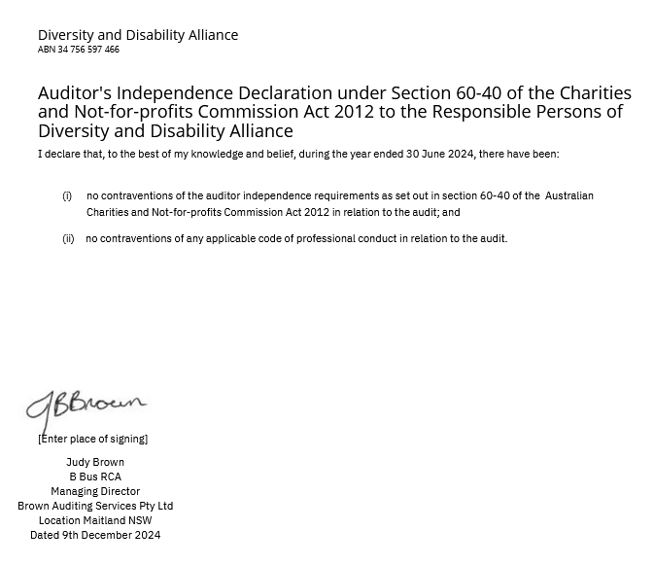

Diversity and Disability Alliance ABN 34 756 597 466
Statement of Profit or Loss and Other Comprehensive Income
For the Year Ended 30 June 2024
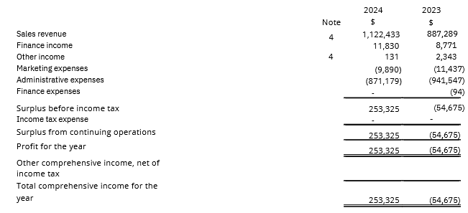
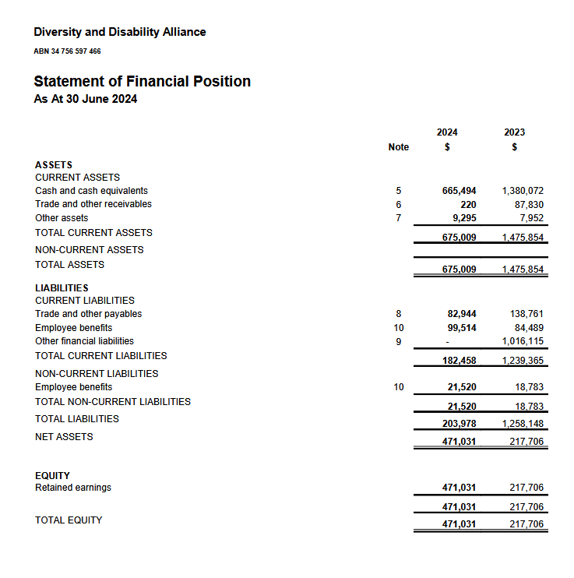
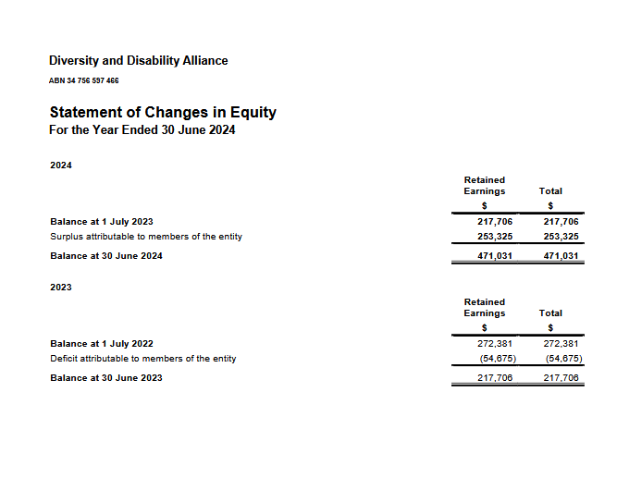
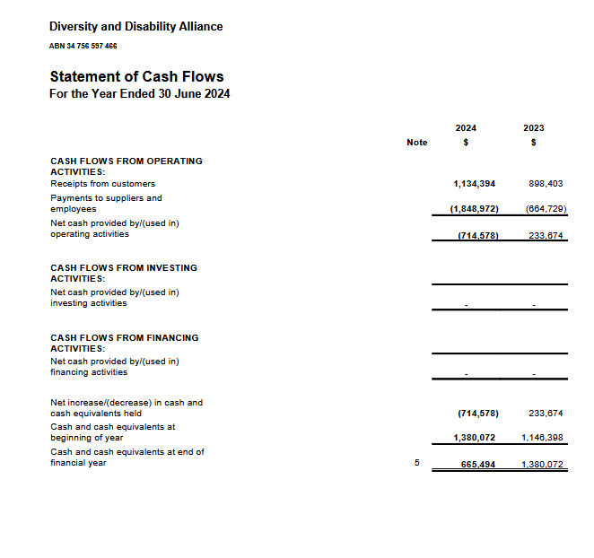
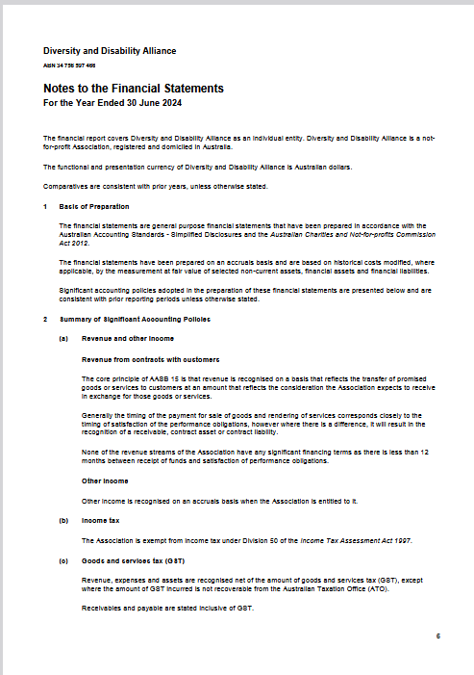
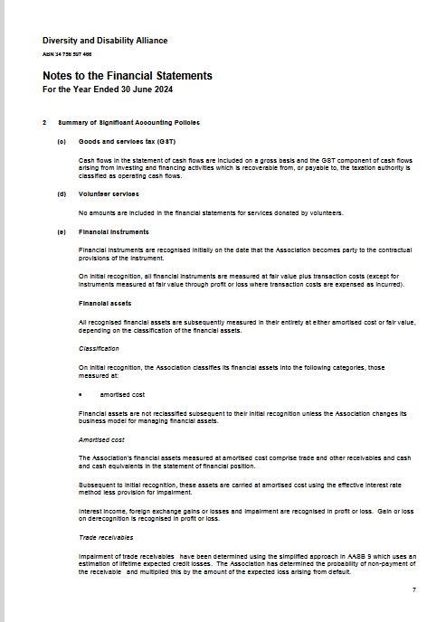
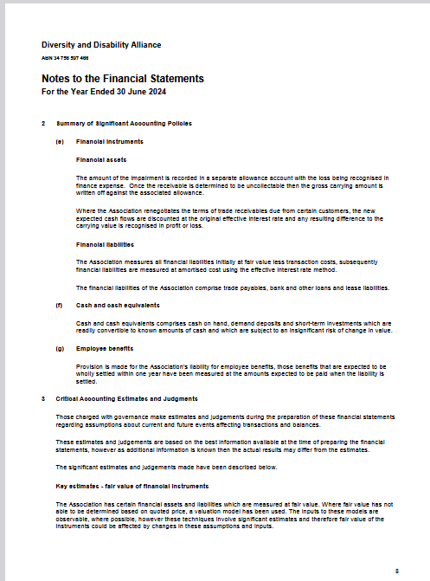

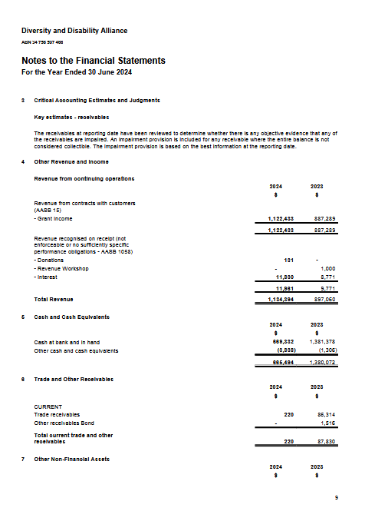
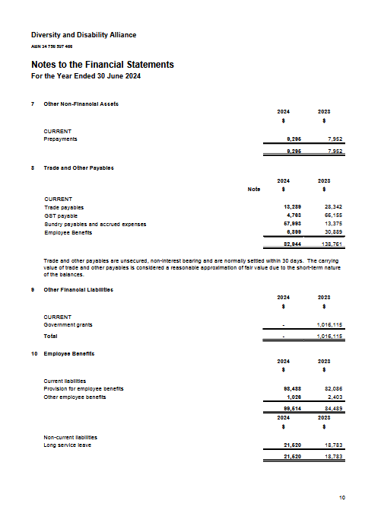
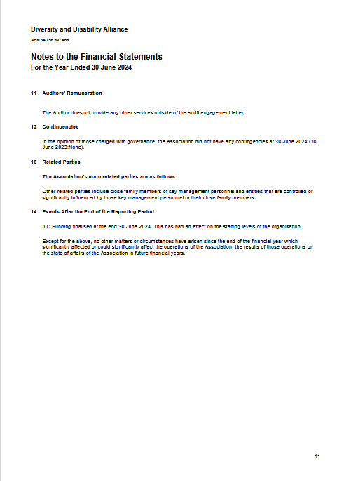

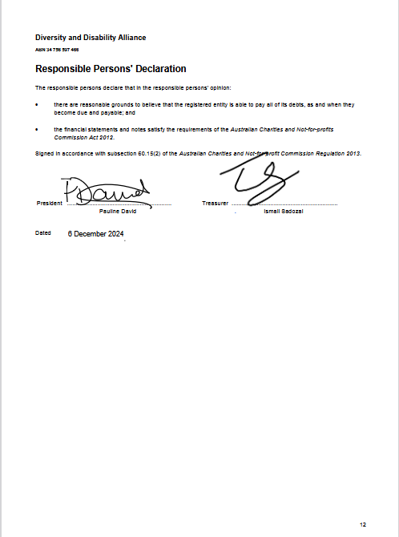

Diversity and Disability Alliance Independent Audit Report to the members of Diversity and Disability Alliance
Opinion We have audited the financial report of Diversity and Disability Alliance, which comprises the statement of financial position as at 30 June 2024, the Detailed Profit or Loss Statement, the statement of changes in equity and the statement of cash flows for the year then ended, and notes to the financial statements, including a summary of significant accounting policies, and the responsible persons' declaration. In our opinion the financial report of Diversity and Disability Alliance has been prepared in accordance with Division 60 of the Australian Charities and Not-for-profits Commission Act 2012, including:
- giving a true and fair view of the Registered Entity's financial position as at 30 June 2024 and of its financial performance for the year ended; and
- complying with Australian Accounting Standards to the extent described in Note 1, and Division 60 of the Australian Charities and Not-for-profits Commission Regulation 2022.
Basis for Opinion We conducted our audit in accordance with Australian Auditing Standards. Our responsibilities under those standards are further described in the Auditor's Responsibilities for the Audit of the Financial Report section of our report. We are independent of the Registered Entity in accordance with the auditor independence requirements of the Australian Charities and Not-for-profits Commission Act 2012 (ACNC Act) and the ethical requirements of the Accounting Professional and Ethical Standards Board's APES 110 Code of Ethics for Professional Accountants (the Code) that are relevant to our audit of the financial report in Australia. We have also fulfilled our other ethical responsibilities in accordance with the Code.
We believe that the audit evidence we have obtained is sufficient and appropriate to provide a basis for our opinion.
Emphasis of Matter - Basis of Accounting We draw attention to Note 1 to the financial report, which describes the basis of accounting. The financial report has been prepared for the purpose of fulfilling the Registered Entity's financial reporting responsibilities under the ACNC Act. As a result, the financial report may not be suitable for another purpose. Our opinion is not modified in respect of this matter.
Responsibilities of Responsible Entities for the Financial Report The responsible persons of the Registered Entity are responsible for the preparation of the financial report that gives a true and fair view and have determined that the basis of preparation described in Note 1 to the financial report is appropriate to meet the requirements of the ACNC Act and the needs of the members. The responsible entities' responsibility also includes such internal control as the responsible entities determine is necessary to enable the preparation of a financial report that gives a true and fair view and is free from material misstatement, whether due to fraud or error.
In preparing the financial report, the responsible persons are responsible for assessing the Registered Entity's ability to continue as a going concern, disclosing, as applicable, matters related to going concern and using the going concern basis of accounting unless the responsible entities either intend to liquidate the Registered Entity or to cease operations, or have no realistic alternative but to do so.
Auditor's Responsibilities for the Audit of the Financial Report Our objectives are to obtain reasonable assurance about whether the financial report as a whole is free from material misstatement, whether due to fraud or error, and to issue an auditor’s report that includes our opinion. Reasonable assurance is a high level of assurance, but is not a guarantee that an audit conducted in accordance with Australian Auditing Standards will always detect a material misstatement when it exists. Misstatements can arise from fraud or error and are considered material if, individually or in the aggregate, they could reasonably be expected to influence the economic decisions of users taken on the basis of the financial report.
As part of an audit in accordance with the Australian Auditing Standards, we exercise professional judgement and maintain professional scepticism throughout the audit. We also:
Identify and assess the risks of material misstatement of the financial report, whether due to fraud or error, design and perform audit procedures responsive to those risks, and obtain audit evidence that is sufficient and appropriate to provide a basis for our opinion. The risk of not detecting a material misstatement resulting from fraud is higher than for one resulting from error, as fraud may involve collusion, forgery, intentional omissions, misrepresentations, or the override of internal control. Obtain an understanding of internal control relevant to the audit in order to design audit procedures that are appropriate in the circumstances, but not for the purpose of expressing an opinion on the effectiveness of the Registered Entity’s internal control. Evaluate the appropriateness of accounting policies used and the reasonableness of accounting estimates and related disclosures made by the responsible entities. Conclude on the appropriateness of the responsible entities’ use of the going concern basis of accounting and, based on the audit evidence obtained, whether a material uncertainty exists related to events or conditions that may cast significant doubt on the Registered Entity’s ability to continue as a going concern. If we conclude that a material uncertainty exists, we are required to draw attention in our auditor’s report to the related disclosures in the financial report or, if such disclosures are inadequate, to modify our opinion. Our conclusions are based on the audit evidence obtained up to the date of our auditor’s report. However, future events or conditions may cause the Registered Entity to cease to continue as a going concern. Evaluate the overall presentation, structure and content of the financial report, including the disclosures, and whether the financial report represents the underlying transactions and events in a manner that achieves fair presentation.
We communicate with those charged with governance regarding, among other matters, the planned scope and timing of the audit and significant audit findings, including any significant deficiencies in internal control that we identify during our audit.
Chartered Accountants
Judy Brown
B Bus RCA
Managing Director
Brown Auditing Services Pty Ltd
Location Maitland NSW
Dated 9th December 2024

